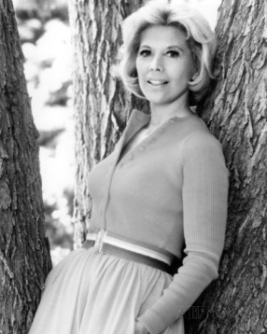
The Mixed Nuts
Set II Last revised on 2016.03.06

II01-This Can't Be Love(KVF).2016.02.07.pdf
II01-This Can't Be Love(KVM).2016.02.07.pdf
II02-In My Merry Oldsmobile(KVF).pdf
II02-In My Merry Oldsmobile(KVM).pdf
II03-High Society Calypso(KV).pdf
II04-Heart Of My Heart(KV).2014.03.23.pdf
II05-Basin Street Blues(KVF).pdf
II05-Basin Street Blues(KVM).pdf
II06-Red Raven Polka(KVF).2016.03.06.pdf
II06-Red Raven Polka(KVM).2016.03.06.pdf
II07-Blue Champagne(KVF).2016.03.06.pdf
II07-Blue Champagne(KVM).2016.03.06.pdf
II17-Yes Sir, That's My Baby(KV).2016.03.06.pdf
II08-If I Knew You Were Coming, I'd Have Baked A Cake(KVF).2013.11.03.pdf
II08-If I Knew You Were Coming, I'd Have Baked A Cake(KVM).2013.11.03.pdf
II09-Buttons And Bows (KVF).2014.05.03.pdf
II09-Buttons And Bows (KVM).2014.05.03.pdf
II10-I'll Walk Alone(KVF).pdf
II10-I'll Walk Alone(KVM).pdf
II11-Dear Hearts And Gentle People(KVD).2016.02.07.pdf
II12-Can't Get Used To Losing You(KVF).2014.07.27.pdf
II12-Can't Get Used To Losing You(KVM).2014.07.27.pdf
II13-That Lucky Old Sun(KV).2016.02.15.pdf
II14-Bye Bye Blues (KVF).pdf
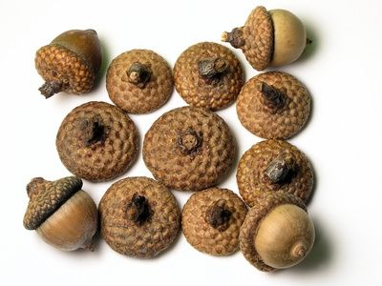
II14-Bye Bye Blues (KVM).pdf
II15-In The Shade Of The Old Apple Tree(KVF).pdf
II15-In The Shade Of The Old Apple Tree(KVM).pdf
II16-I Get Ideas(KVF).2015.03.30.pdf
II16-I Get Ideas(KVM).pdf
II17-Yes Sir, That's My Baby(KV).2016.03.06.pdf

